RESUME
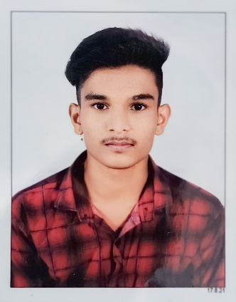
NAME: RATHOD ROHAN SHRIVINODBHAI
ADD: 61/62, KHODIYAR NAGAR
SOCIETY, RANOLI, VADODARA, 391350
CONTACT NO: 6353788467
E-MAIL: rathodrohan498@gmail.com
CARRIER & OBJECTIVE:
Aspiring to work an organization that offers responsible position affair I can utilize my skills and capabilities to carve a position for myself and effectively deliver but contributing the organizations aspiration.
Education details:
Course | University/School | Month/Year | Percentage
S.S.C | YAGANIK VIDHYALAY | MARCH-2019 | 65%
H.S.C | YAGANIK VIDHYALAY | MAY-2021 | 56%
BASIC + CCC | TERA SOFT COMPUTER TRAINING INSTITUTE | August-2018 | 77%
TALLY + GST | TERA SOFT COMPUTER TRAINING INSTITUTE | November-2022 | 80%
MY STRONG POINT: I HAVE GOOD COMMUNICATION AND.
I AM GOOD LISTENER AS WELL AS GOOD SPEAKER.
PERSONAL INFORMATION:
NAME: RATHOD ROHAN SHRIVINODBHAI
D.O.B.: 24/08/2002
LANGUAGE: HINDI, GUJARATI, ENGLISH
Marital Status: UNMARRIED
DATE:
PLACE: VADODARA SIGNATURE

